**Ideation Phase**

**Define the Problem Statements**

|  |  |
| --- | --- |
| Date | 15 October 2022 |
| Team ID | PNT2022TMID27964 |
| Project Name | Smart farmer: IoT enabled smart farming |
| Maximum Marks | 2 Marks |

**Customer Problem Statement:**

A young farmer who want to start his farming business by growing various crops on his field. Since he is young he may not know about the traditional methods of farming. But the farmer is literate and knows how to operate applications on certain degree. Therefore by building a mobile application which will show data about various factors such as temperature, humidity, pH value of the soil etc. Also the farmer can operate motor pump from remote area to turn on using the same mobile application and can also set a schedule based on when to irrigate the field. This will ease the farmer’s work and it will reduce the manpower required for farming. Thereby the farmer can reduce the cost of labour be more efficient.

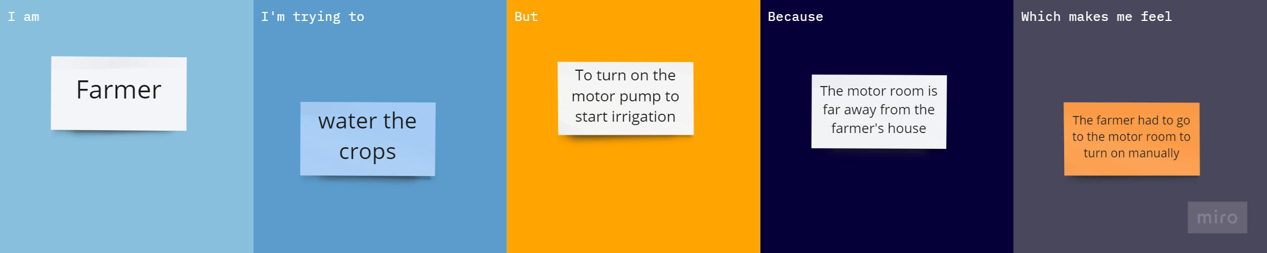

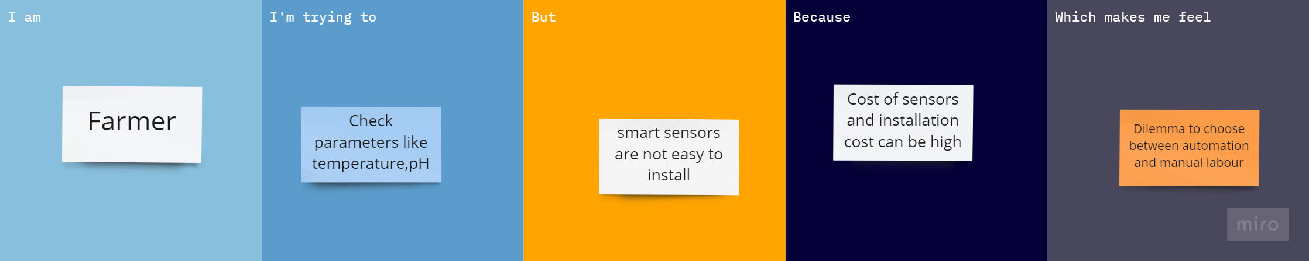

|  |  |  |  |  |  |
| --- | --- | --- | --- | --- | --- |
| **Problem Statement (PS)** | **I am (Customer)** | **I’m trying to** | **But** | **Because** | **Which makes me feel** |
| PS-1 | Farmer | Water the crops | To turn on the motor pump to start irrigation | Motor room maybe far away from house | Burden of turning on motor and watering plants manually |
| PS-2 | Farmer | To check parameters like temperature, pH, moisture | Smart sensors may not be easy to install | Cost of sensors and installation can be high | Dilemma to choose between automation and manual labour |